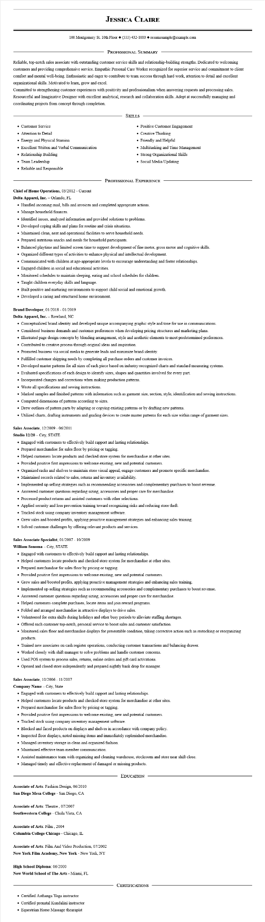
JESSICA CLAIRE
100 Montgomery St. 10th Floor (555) 432-1000◆ resumesample@example.com
PROFESSIONAL SUMMARY
Reliable, top-notch sales associate with outstanding customer service skills and relationship-building strengths. Dedicated to welcoming customers and providing comprehensive service. Empathic Personal Care Worker recognized for superior service and commitment to client comfort and mental well-being. Enthusiastic and eager to contribute to team success through hard work, attention to detail and excellent organizational skills. Motivated to learn, grow and excel.
Committed to strengthening customer experiences with positivity and professionalism when answering requests and processing sales. Resourceful and Imaginative Designer with excellent analytical, research and collaboration skills. Adept at successfully managing and coordinating projects from concept through completion.
• Customer Service
• Attention to Detail
• Energy and Physical Stamina
• Excellent Written and Verbal Communication
• Relationship Building
• Team Leadership
• Reliable and Responsible
SKILLS
• Positive Customer Engagement
• Creative Thinking
• Friendly and Helpful
• Multitasking and Time Management
• Strong Organizational Skills • Social Media Updating
Chief of Home Operations, 03/2012 - Current
Delta Apparel, Inc. - Orlando, FL
PROFESSIONAL EXPERIENCE
• Handled incoming mail, bills and invoices and completed appropriate actions. • Manage household finances.
• Identified issues, analyzed information and provided solutions to problems.
• Developed coping skills and plans for routine and crisis situations.
• Maintained clean, neat and operational facilities to serve household needs.
• Prepared nutritious snacks and meals for household participants.
• Balanced playtime and limited screen time to support development of fine motor, gross motor and cognitive skills.
• Organized different types of activities to enhance physical and intellectual development.
• Communicated with children at age-appropriate levels to encourage understanding and foster relationships.
• Engaged children in social and educational activities.
• Monitored schedules to maintain sleeping, eating and school schedules for children.
• Taught children everyday skills and language.
• Built positive and nurturing environments to support child social and emotional growth.
• Developed a caring and structured home environment.
Brand Developer, 01/2018 - 01/2019
Delta Apparel, Inc. - Rowland, NC
• Conceptualized brand identity and developed unique accompanying graphic style and tone for use in communications.
• Considered business demands and customer preferences when developing pricing structures and marketing plans.
• Illustrated page design concepts by blending arrangement, style and aesthetic elements to meet predetermined preferences.
• Contributed to creative process through original ideas and inspiration.
• Promoted business via social media to generate leads and maximize brand identity.
• Fulfilled customer shipping needs by completing all purchase orders and customer invoices.
• Developed master patterns for all sizes of each piece based on industry-recognized charts and standard measuring systems.
• Evaluated specifications of each design to identify sizes, shapes and quantities involved for every part.
• Incorporated changes and corrections when making production patterns.
• Wrote all specifications and sewing instructions.
• Marked samples and finished patterns with information such as garment size, section, style, identification and sewing instructions.
• Computed dimensions of patterns according to sizes.
• Drew outlines of pattern parts by adapting or copying existing patterns or by drafting new patterns.
• Utilized charts, drafting instruments and grading devices to create master patterns for each size within range of garment sizes.
Sales Associate, 12/2009 - 06/2011
Studio 12/20-City, STATE
• Engaged with customers to effectively build rapport and lasting relationships.
• Prepared merchandise for sales floor by pricing or tagging.
• Helped customers locate products and checked store system for merchandise at other sites.
• Provided positive first impressions to welcome existing, new and potential customers.
• Organized racks and shelves to maintain store visual appeal, engage customers and promote specific merchandise.
• Maintained records related to sales, returns and inventory availability.
• Implemented up-selling strategies such as recommending accessories and complementary purchases to boost revenue.
• Answered customer questions regarding sizing, accessories and proper care for merchandise.
• Processed product returns and assisted customers with other selections.
• Applied security and loss prevention training toward recognizing risks and reducing store theft.
• Tracked stock using company inventory management software.
• Grew sales and boosted profits, applying proactive management strategies and enhancing sales training.
• Solved customer challenges by offering relevant products and services.
Sales Associate Specialist, 01/2007-10/2009
William Sonoma City, STATE
• Engaged with customers to effectively build rapport and lasting relationships.
• Helped customers locate products and checked store system for merchandise at other sites.
• Prepared merchandise for sales floor by pricing or tagging.
• Provided positive first impressions to welcome existing, new and potential customers.
• Grew sales and boosted profits, applying proactive management strategies and enhancing sales training.
• Implemented up-selling strategies such as recommending accessories and complementary purchases to boost revenue.
• Answered customer questions regarding sizing, accessories and proper care for merchandise.
• Helped customers complete purchases, locate items and join reward programs.
• Folded and arranged merchandise in attractive displays to drive sales.
• Volunteered for extra shifts during holidays and other busy periods to alleviate staffing shortages.
• Offered each customer top-notch, personal service to boost sales and customer satisfaction.
• Monitored sales floor and merchandise displays for presentable condition, taking corrective action such as restocking or reorganizing
products.
• Trained new associates on cash register operations, conducting customer transactions and balancing drawer.
• Worked closely with shift manager to solve problems and handle customer concerns.
• Used POS system to process sales, returns, online orders and gift card activations.
• Opened and closed store independently and prepared nightly bank drop for manager.
Sales Associate, 10/2006- 11/2007
Company Name - City, State
• Engaged with customers to effectively build rapport and lasting relationships.
• Helped customers locate products and checked store system for merchandise at other sites.
• Prepared merchandise for sales floor by pricing or tagging.
• Provided positive first impressions to welcome existing, new and potential customers.
• Tracked stock using company inventory management software.
• Blocked and faced products on displays and shelves in accordance with company policy.
• Inspected floor displays, noted missing items and immediately replenished merchandise.
• Managed inventory storage in clean and organized fashion.
• Maintained effective team member communication.
• Assisted maintenance team with organizing and cleaning warehouse, stockroom and store near shift close.
• Managed timely and effective replacement of damaged or missing products.
Associate of Arts: Fashion Design, 06/2010
San Diego Mesa College - San Diego, CA
Associate of Arts: Theatre, 07/2007 Southwestern College - Chula Vista, CA
Associate of Arts: Film, 2004 Columbia College Chicago - Chicago, IL
Associate of Arts: Film And Video Production, 07/2002 New York Film Academy, New York - New York, NY
High School Diploma: 06/2000
New World School of The Arts - Miami, FL
• Certified Asthanga Yoga instructor
• Certified prenatal Kundalini instructor
• Equestrian Horse Massage thearapist
EDUCATION
CERTIFICATIONS

